B&B EAP

B&B Systems
627 Madison
Waukesha, Wisconsin 53188
414-544-5988

Table of Contents

Add New Clients 3
Client information, contacts and referrals on ONE screen 6
Automatically Add Case data 7
If employee data file available,-find employee & Add Client demographics directly. 7
Automaticaly Add Referral data 8
Resource directory pops up when adding referrals 8
Contact Details Screen – unlimited # of contacts 9
Referrals Detail screen – unlimited # of referrals 10
Assessment Screen 11
Control your own multiple choice values in picklists 12
Graphing Added – graph any data 13
DSMIV codes screen 14
Edit Base numbers - Employees, Dependents, or Factor 15
Used to calculate utilization 15
Encryption of data 16
Sample features 17
Reports 18
SAMPLE Summary Report - Counts & Percentages for demographics 19
Other Reports 20

Add New Clients

There are two ways to add new cases.

The first method is to simply press the "add client" button. This will add a blank client record. You will be prompted for a new ID# for this new record. It needs to be unique, and the default number will be the year and a numerically incremented counter.

The second method is to press the "add from employee file" button. This option is only applicable if a file of demographic information (name, address, etc.) is available. A typical file is a file of employees. You will be presented with a screen showing all of the demographic records. At the top, you can enter data such as name or SSN that will help find the record you desire. Once that record is located (it will be the selected record in the grid at the bottom of the screen), press the "copy" button to copy this data to a new client record (Note: only fields with matching names in both files will be copied)

The ID# will be the same as the ID# (or employee number) from this demographic file.

Hint: You can print the structure of the sample employee/demographic file, emaster.dbf, from the demographic screen.

Add New Contacts
Press the "add contact" button to add a blank record to the contacts file. Note: this record will automatically contain the ID # from the client record (This number should not be changed).

Once added, you can edit the Staff ID (initially, the value in your new contact record is the same value as the client record). You can also edit the date (initially defaults to current date), the amount of time (minutes) and the type of contact made.

Contact types: There are different types of contacts, broken down into two main ways of making contacts, either PER (in-person) or PHO (over the phone).

They are:
PER Intake OR PHO Intake
PER Brief Consultation OR PHO Brief Consultation
PER Case Management OR PHO Case Management
PER Clinical Consultation OR PHO Clinical Consultation
PER Follow-up Contact OR PHO Follow-up Contact
PER Information Consultation OR PHO Information Consultation
PER Intake Assessment OR PHO Intake Assessment

(Hint: like most other values in your system, like disposition codes of greatly improved or resolved, these values can be changed. But some values are used in reports. So be cautious. Become familiar with the system first. If changes need to be made, you may need to have your reports customized by B&B Systems).

Add New Referrals

There are two ways to add referrals.

The first way is to press the "add referral" button. This will add a blank record to the referral file. Again, the ID# will be repeated from the client record. All other data can be edited.

The second way is to press the "add from resource file" button. This will display a screen of referral resources. You can add your own resources, deleted the sample resources, etc. Once you selected the referral you wish to make to your client, select the "copy data & exit" button. All data in the resource file will be copied to a new referral record (for those fields where the field names match in both files).

Staff ID#
This number or code identifies the caseworker for the client. This ID is commonly derived from the initials (first/middle/last)

The first option is to let this ID# be derived for you, not only to reduce data entry, but to ensure the caseworker is accurately identified.. If your system is installed in a network, BB EAP will automatically use the first 3 letters of the network logon to identify the user. If the first three characters of all the network logons are unique, this is a simple method to identify the current user. This method allows all users to see all client records.

The second option is to use the maintenance option to install password protection. This method will prompt the user for a password. Once it is decided to install passwords, the administrator will add the individual users. After adding users, when a user attempts to use the system, the password will requested. This password will determine the user and the first/middle and last initials entered by the administrator will be the default StaffID code. AND, if the user has a security level less than the administrator, the user will only be able to see client records ASSIGNED to him/her. (Thus, Only administrators can see all records).

If passwords are installed, a third option becomes available. This option will again restrict the user to seeing only his/her client records, but will not prompt the user for a password. The administrator needs to select "USE NETWORK LOGON ID" option in the users maintenance screen. When the user logs on, the system searches for users having 3 initials that match the first 3 letters of the logon id. If found, the password prompt is bypassed. (Note: administrators must add users with initials that match the logons, or edit the logons to match the initials) Also, initials should be unique. Fake initials are allowed.

Client information, contacts and referrals on ONE screen

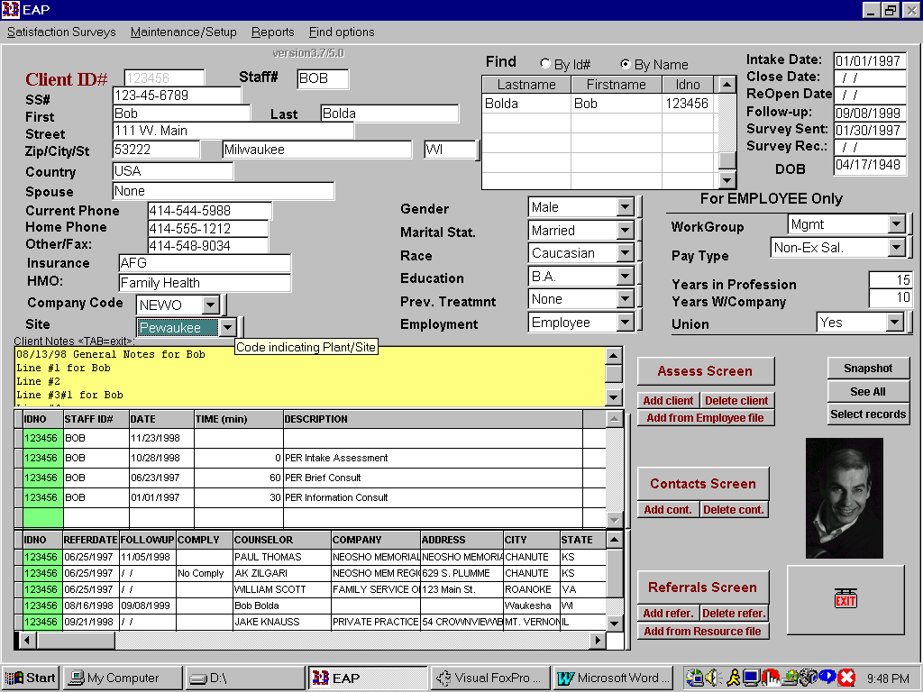

Automatically Add Case data

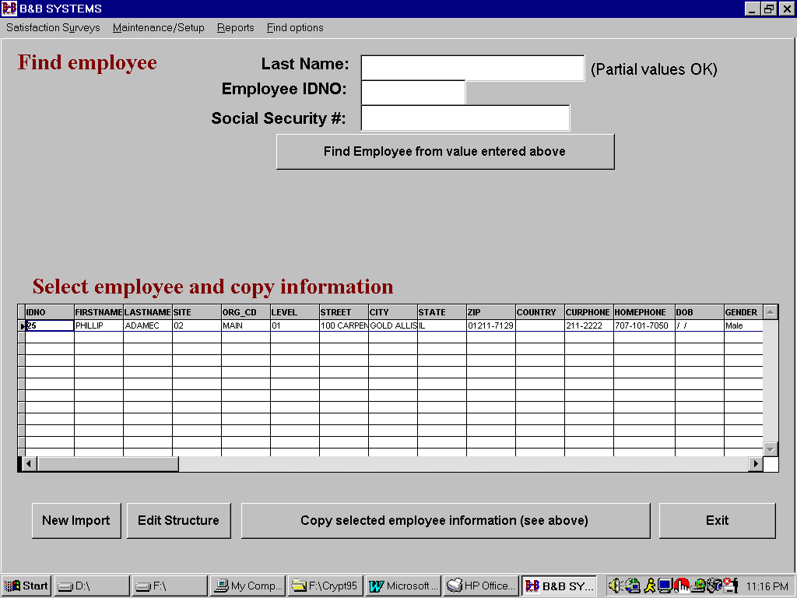
If employee data file available,-find employee & Add Client demographics directly.

Automatically Add Referral data

Resource directory pops up when adding referrals

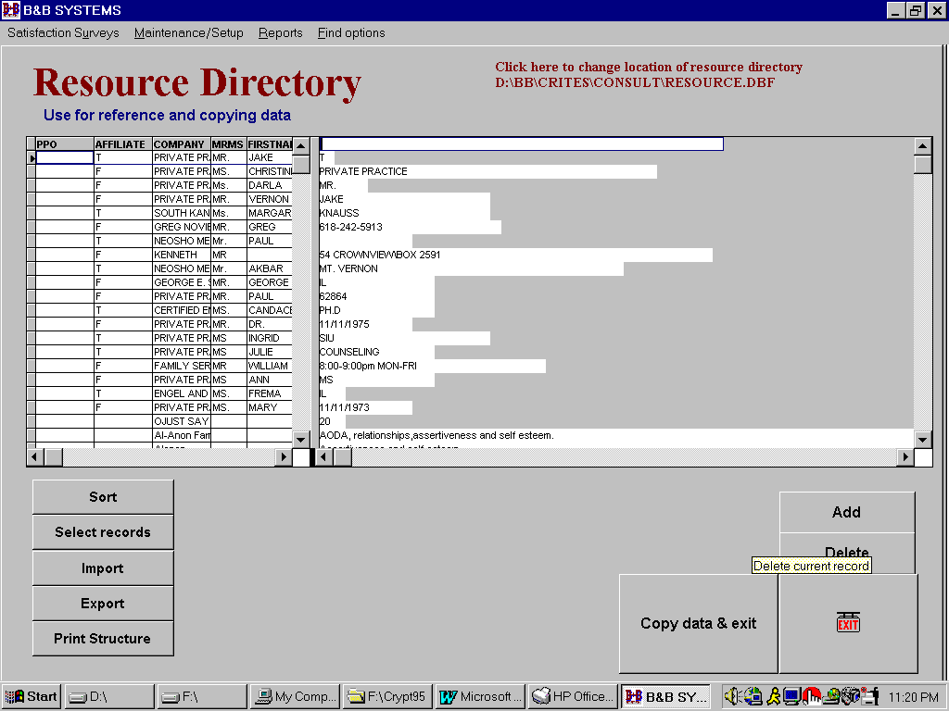

Contact Details Screen – unlimited # of contacts

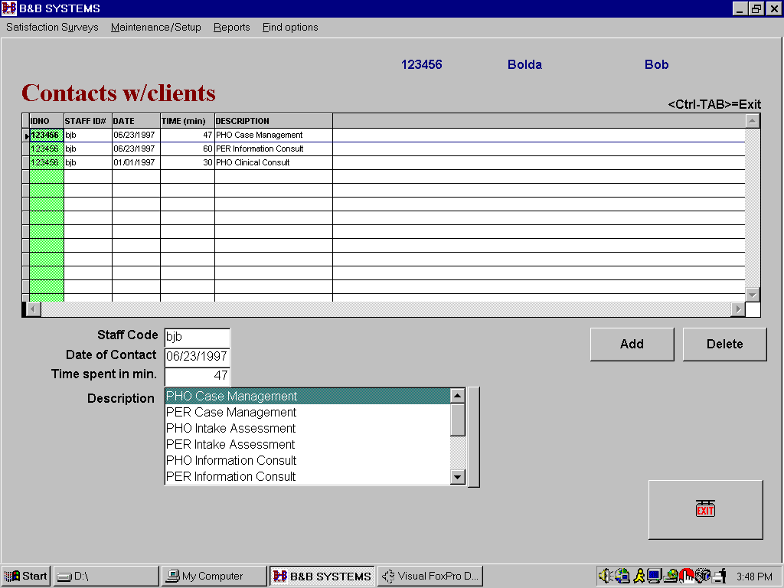

Referrals Detail screen – unlimited # of referrals

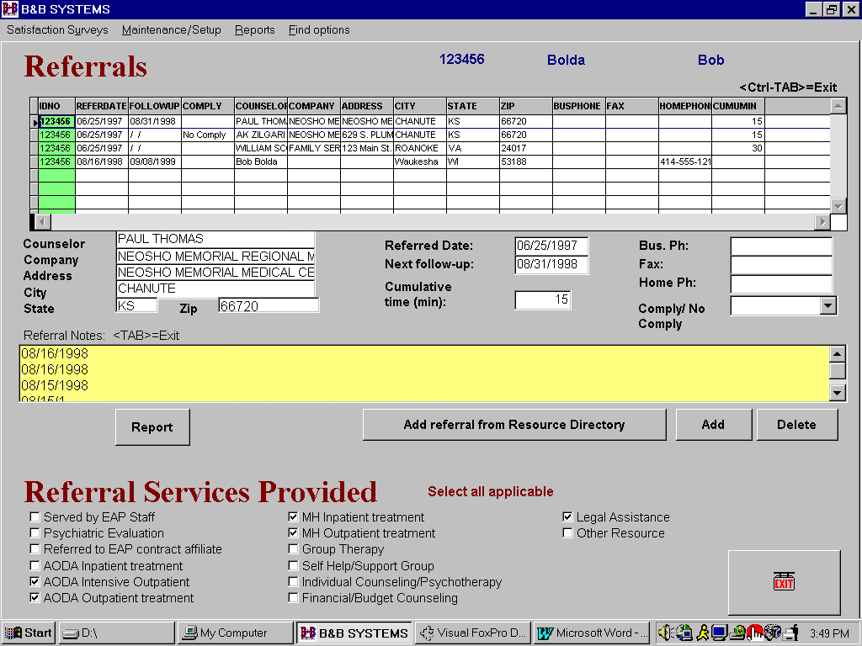

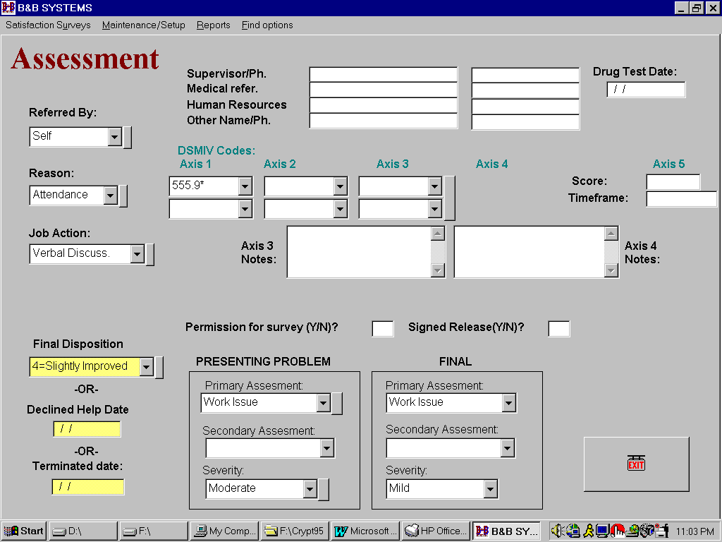
Assessment Screen

Control your own multiple choice values in picklists

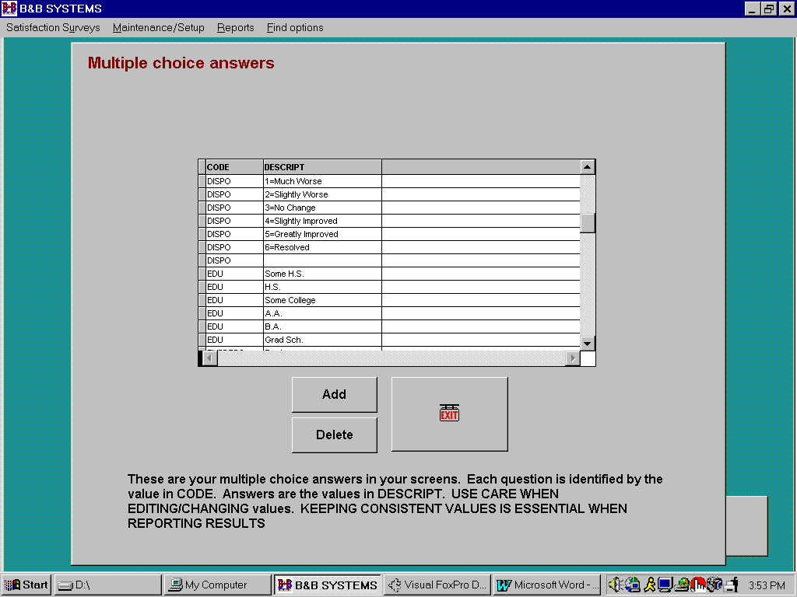

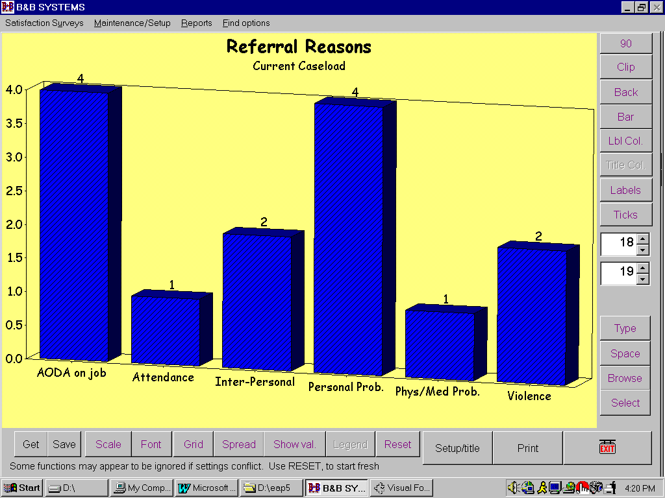
Graphing Added – graph any data

DSMIV codes screen

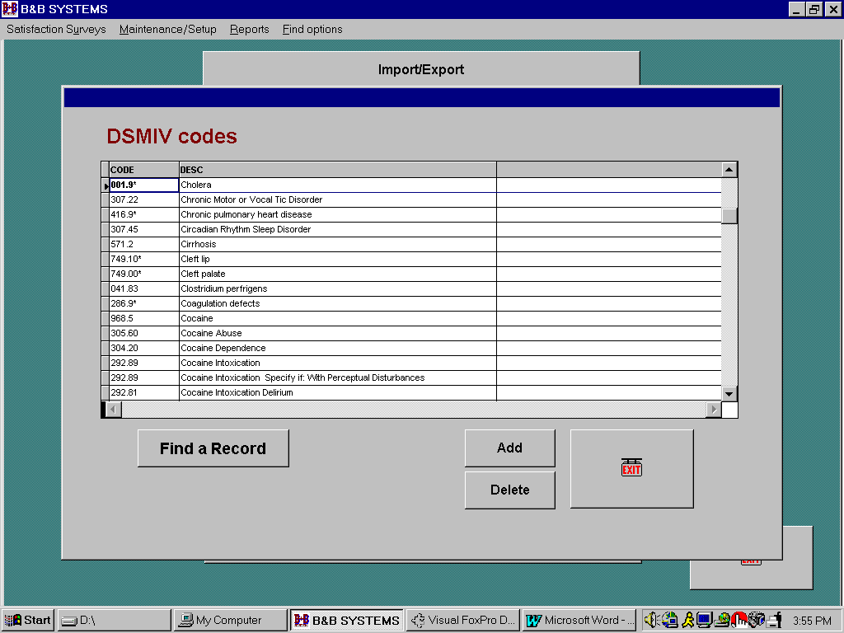

Edit Base numbers - Employees, Dependents, or Factor

Used to calculate utilization

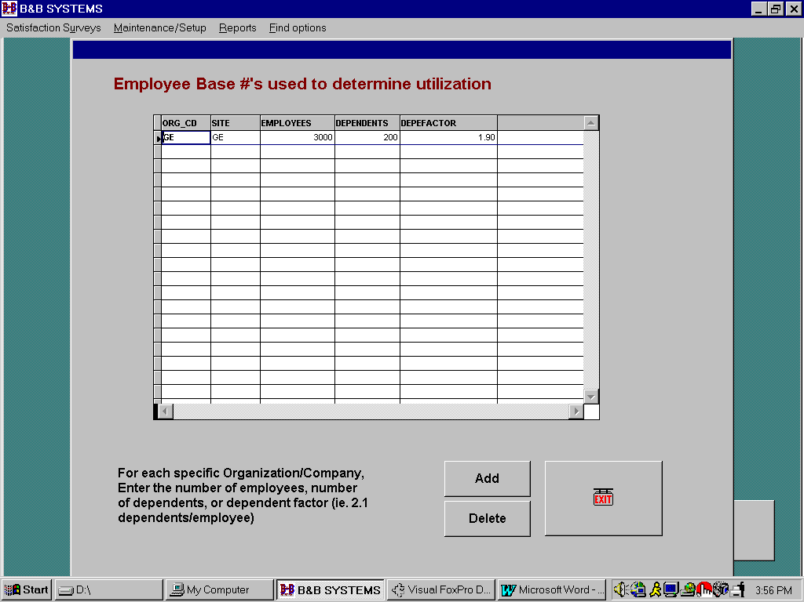

Encryption of data
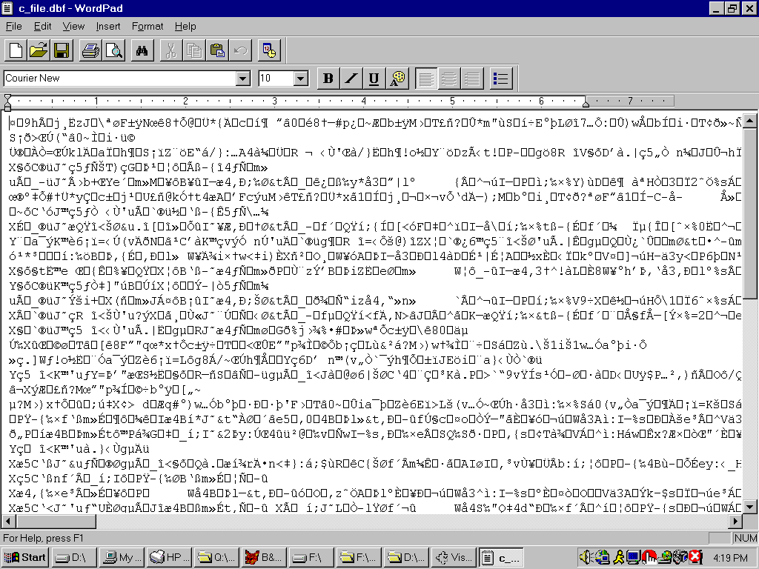
(Sample of data when trying to access data outside system)

Sample features
* Unlimited number of Contacts (in-house)
* Unlimited number of Referrals (out-of-house)
(Incl. sample referrals/resource file)
* Direct import of data from employee files
* Direct import of data from resource/referral file
* Encrypted data - no one can see any data outside the system
(Encryption currently only available for WIN95)
* Unlimited notes
* Supports DSMIV coding
* Graphing capability
* Satisfaction surveys
* Coming! Speech Recognition - add unlimited notes (Using IBM's ViaVoice)
Put your cursor into any of the note boxes and say "Dictate Direct".
There is also a Text-To-Speech function, which will read/speak your entered text.
* Ability to show client pictures (if available)
* Case data summarized in one screen
* Import/Export data
* Security/Password option

Reports

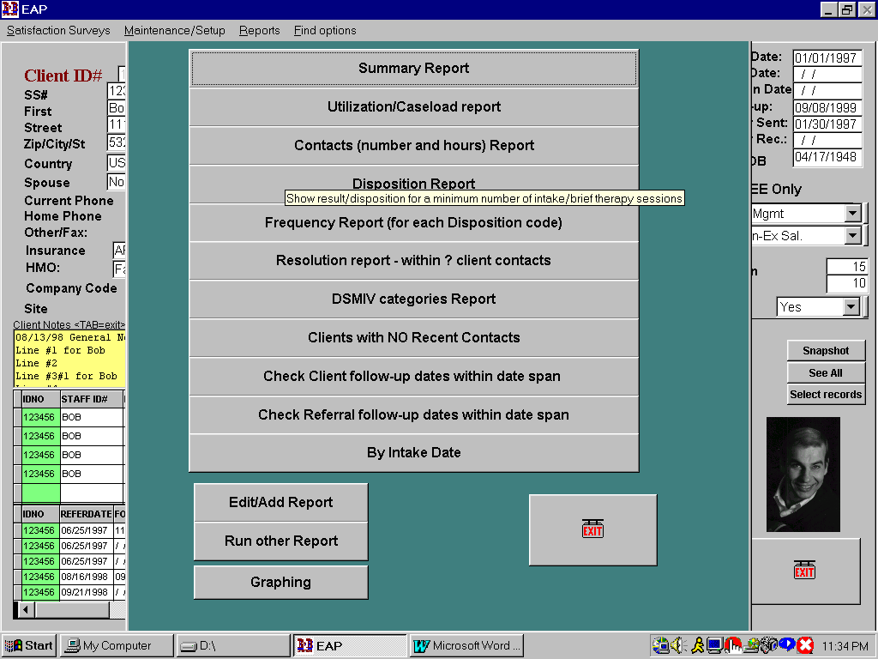

SAMPLE Summary Report - Counts & Percentages for demographics

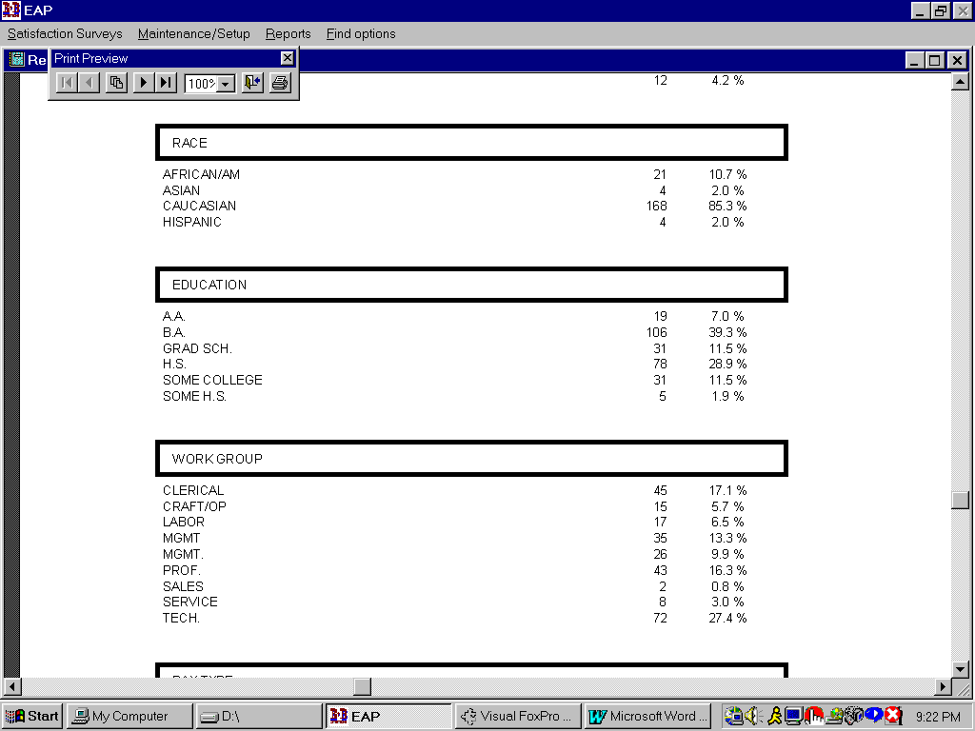

Other Reports
Caseload/Utilization - Current Caseload & Utilization based on base loads (employees, spouses or factors).

Contacts Report - For each staff ID and each Company/Organization and Site.

Disposition Report - Summarizes # of intake or brief therapy sessions for closed cases and the dispositions of each case.

Frequency Report - # of closed cases in each disposition category.

Resolved Report - # of client contacts required to "resolve" or "greatly improve" cases.

Cases w/o Recent activity (in last ? days) Report

Follow-ups due in cases file within ? days span Report

Follow-ups due in referrals file within ? days span Report

By Intake date Report

User custom Reports

Case information Summary

Error! No index entries found.

